Name: Jaswanth babu R R
Reg no: 192512341
Course code: advanced wireless communication system
Course code: ECE5610

Experiment: 5 :MATLAB – Simulation and Throughput Analysis of LTE-Advanced Carrier Aggregation

Aim:
To simulate an LTE-Advanced wireless link using carrier aggregation and analyze the effect of aggregating multiple component carriers on available transmission bandwidth and estimated throughput using MATLAB.

Objectives:
- To model an LTE-Advanced link using one component carrier.
- To extend the model to use multiple aggregated component carriers.
- To compare estimated throughput for different carrier bandwidths.
- To explain how carrier aggregation increases available transmission bandwidth.

Software Required:
- MATLAB

Objective – 1: Model One Component Carrier

MATLAB Program:

clc; clear; close all;
BW1 = 20; % Component carrier bandwidth (MHz)
SE = 4; % Spectral efficiency (bits/s/Hz)
Ncc = 1; % Number of component carriers
BWagg = BW1*Ncc;
Throughput = BWagg*SE; % Mbps for MHz × bits/s/Hz
disp('Single Component Carrier')
disp(['Bandwidth = ',num2str(BWagg),' MHz'])
disp(['Estimated Throughput = ',num2str(Throughput),' Mbps'])
figure
bar(Ncc,Throughput)
grid on
xlabel('Number of Component Carriers')
ylabel('Estimated Throughput (Mbps)')
title('LTE-Advanced Single Carrier Throughput')

Output:

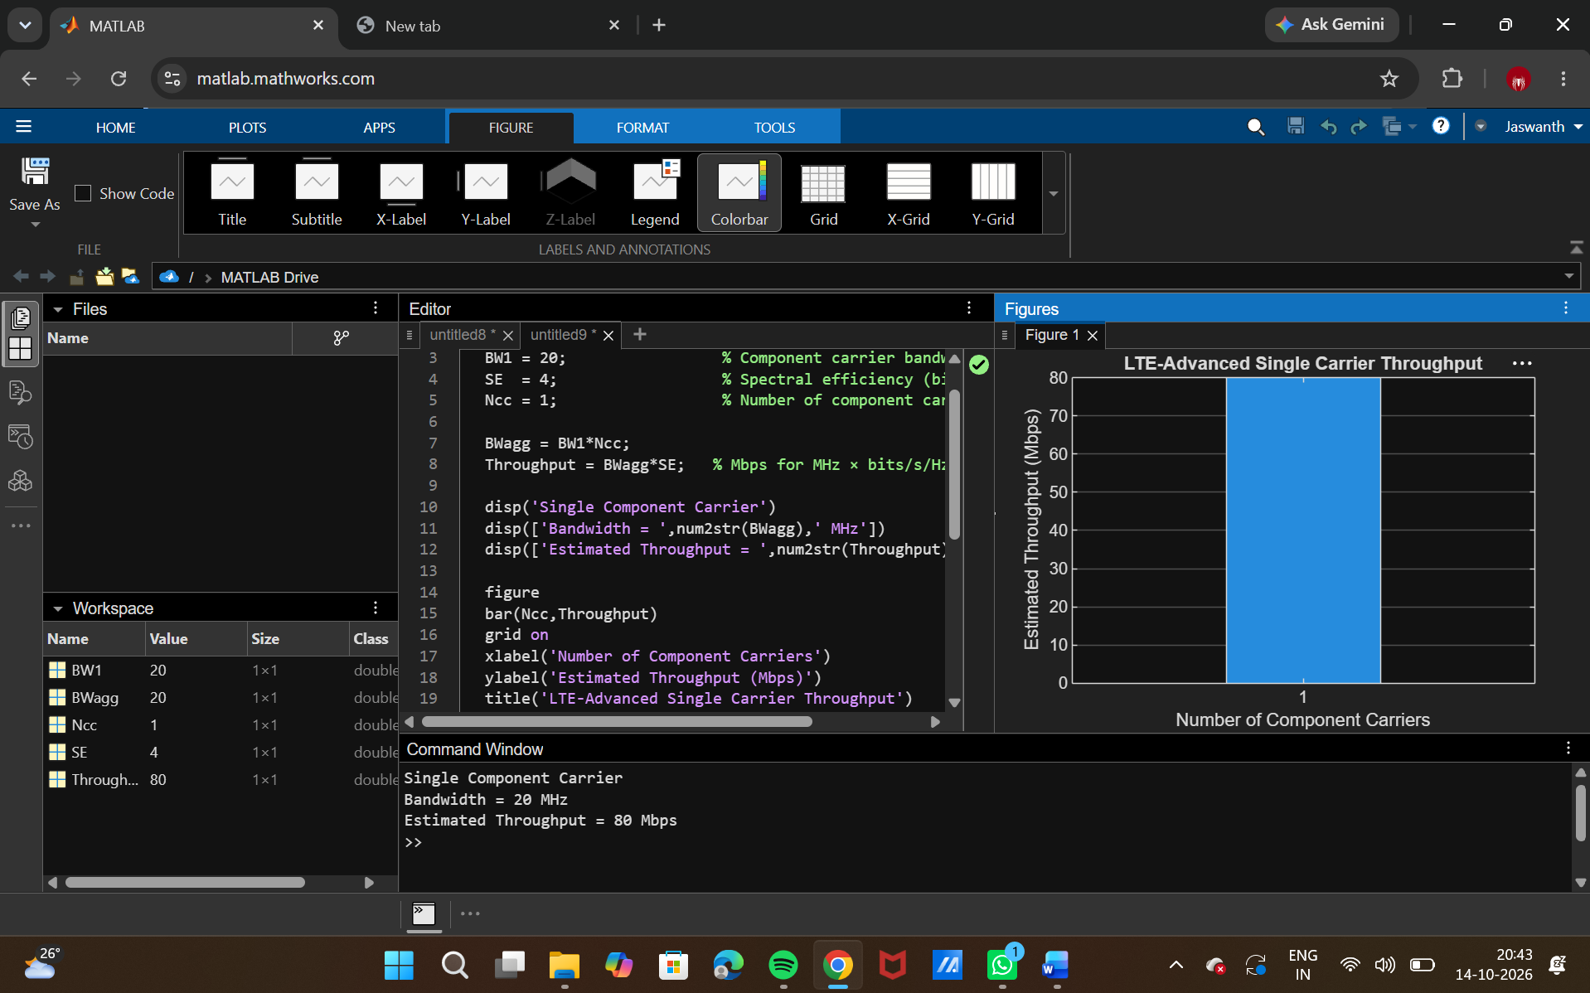

Objective – 2: Extend to Multiple Aggregated Component Carriers

MATLAB Program
clc; clear; close all;
BWcc = 20; % MHz per component carrier
SE = 4; % bits/s/Hz
CC = [1 2 3]; % Number of component carriers
AggBW = BWcc .* CC; % MHz
Throughput = AggBW .* SE; % Mbps
disp('CC Aggregated BW (MHz) Estimated Throughput (Mbps)')
disp([CC' AggBW' Throughput'])
figure
bar(CC,Throughput)
grid on
xlabel('Number of Aggregated Component Carriers')
ylabel('Estimated Throughput (Mbps)')
title('LTE-Advanced Carrier Aggregation Throughput')

Output:

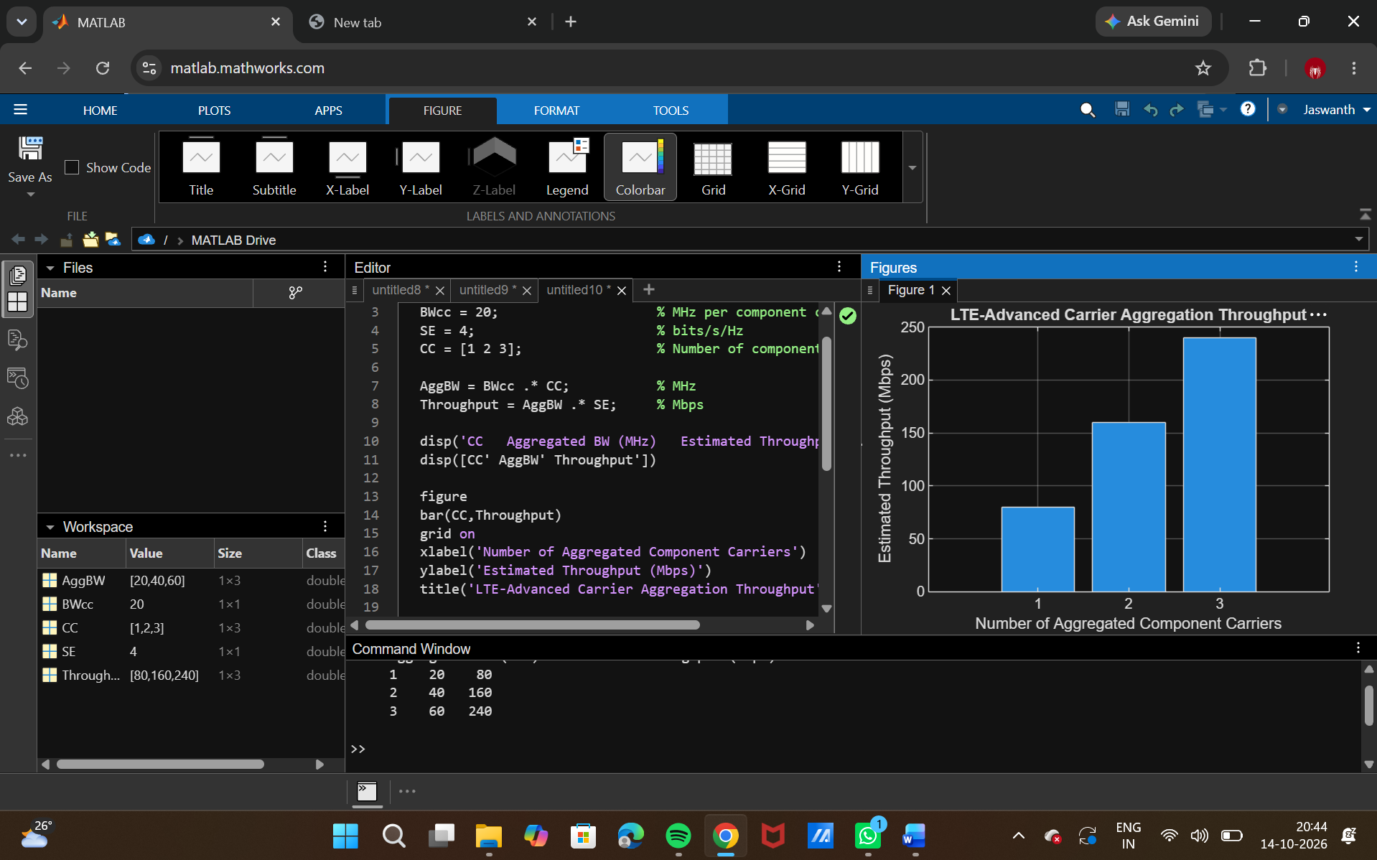

Objective – 3: Compare Estimated Throughput for Different Carrier Bandwidths

MATLAB Program
clc; clear; close all;
BW = [5 10 15 20]; % Carrier bandwidths (MHz)
SE = 4; % bits/s/Hz
TP = BW .* SE; % Estimated throughput (Mbps)
disp('Bandwidth (MHz) Throughput (Mbps)')
disp([BW' TP'])
figure
plot(BW,TP,'o-','LineWidth',2)
grid on
xlabel('Carrier Bandwidth (MHz)')
ylabel('Estimated Throughput (Mbps)')
title('Throughput vs Component Carrier Bandwidth')

Output:

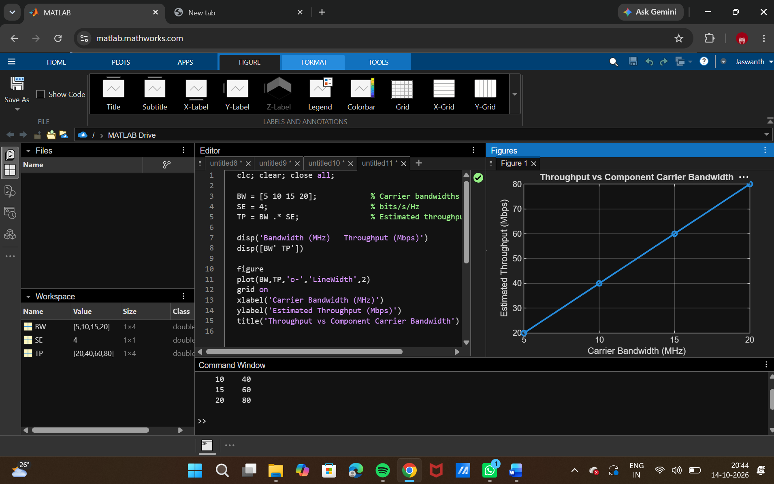

Objective – 4: Explain the Effect of Carrier Aggregation
The total available bandwidth is obtained by combining the component carriers. Under the simplified constant spectral-efficiency model, throughput increases approximately in proportion to the aggregated bandwidth. In a practical LTE-Advanced system, the actual throughput is also influenced by modulation, coding, channel quality, control overhead, scheduling and radio conditions.

Result:
- The LTE-Advanced link was successfully modeled using a single component carrier.
- Multiple component carriers were aggregated and the resulting bandwidth and estimated throughput were calculated.
- Throughput was compared for different carrier bandwidths.
- The simulation demonstrated that carrier aggregation increases available transmission bandwidth and can increase achievable throughput.

